Secrets of Your ADHD Brain

Most people are neurologically equipped to determine what’s important and get motivated to do it, even when it doesn’t interest them. Then there are the rest of us, who have attention deficit (and the ADHD brain that goes along with it).
BY WILLIAM DODSON, M.D.
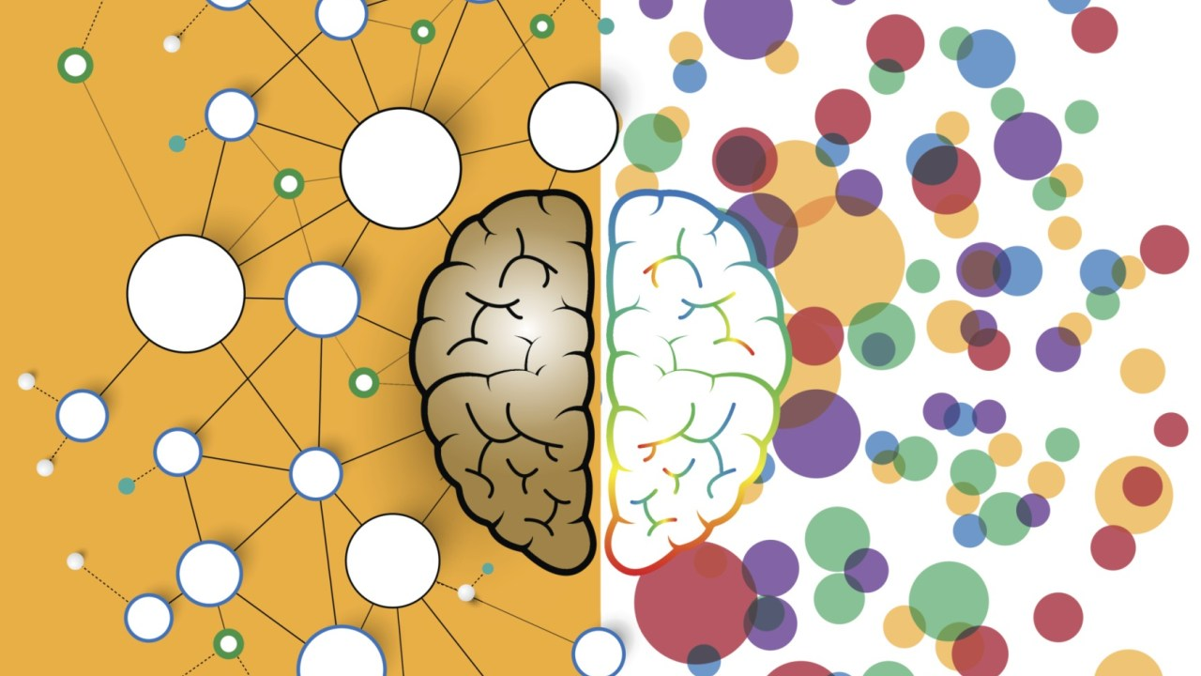

ADHD is a confusing, contradictory, inconsistent, and frustrating condition. It is overwhelming to people who live with it every day. The diagnostic criteria that have been used for the last 40 years leave many people wondering whether they have the condition or not. Diagnosticians have long lists of symptoms to sort through and check off. The Diagnostic and Statistical Manual of Mental Disorders has 18 criteria, and other symptom lists cite as many as 100 traits.
Practitioners, including myself, have been trying to establish a simpler, clearer way to understand the impairments of ADHD. We have been looking for the “bright and shining line” that defines the condition, explains the source of impairments, and gives direction as to what to do about it.
My work for the last decade suggests that we have been missing something important about the fundamental nature of the ADHD brain. I went back to the experts on the condition — the hundreds of people and their families I worked with who were diagnosed with it — to confirm my hypothesis. My goal was to look for the feature that everyone with ADHD has, and that neurotypical people don’t have.
I found it. It is the ADHD nervous system, a unique and special creation that regulates attention and emotions in different ways than the nervous system in those without the condition.

The ADHD Zone
Almost every one of my patients and their families want to drop the term Attention Deficit Hyperactivity Disorder, because it describes the opposite of what they experience every moment of their lives. It is hard to call something a disorder when it imparts many positives. ADHD is not a damaged or defective nervous system. It is a nervous system that works well using its own set of rules.
Despite ADHD’s association with learning disabilities, most people with an ADHD nervous system have significantly higher-than-average IQs. They also use that higher IQ in different ways than neurotypical people. By the time most people with the condition reach high school, they are able to tackle problems that stump everyone else, and can jump to solutions that no one else saw.
The vast majority of adults with an ADHD nervous system are not overtly hyperactive. They are hyperactive internally.
Those with the condition don’t have a shortage of attention. They pay too much attention to everything. Most people with unmedicated ADHD have four or five things going on in their minds at once. The hallmark of the ADHD nervous system is not attention deficit, but inconsistent attention.
Everyone with ADHD knows that they can “get in the zone” at least four or five times a day. When they are in the zone, they have no impairments, and the executive function deficits they may have had before entering the zone disappear. People with ADHD know that they are bright and clever, but they are never sure whether their abilities will show up when they need them. The fact that symptoms and impairments come and go throughout the day is the defining trait of ADHD. It makes the condition mystifying and frustrating.
People with ADHD primarily get in the zone by being interested in, or intrigued by, what they are doing. I call it an interest-based nervous system. Judgmental friends and family see this as being unreliable or self-serving. When friends say, “You can do the things you like,” they are describing the essence of the ADHD nervous system.
ADHD individuals also get in the zone when they are challenged or thrown into a competitive environment. Sometimes a new or novel task attracts their attention. Novelty is short-lived, though, and everything gets old after a while.
Most people with an ADHD nervous system can engage in tasks and access their abilities when the task is urgent — a do-or-die deadline, for instance. This is why procrastination is an almost universal impairment in people with ADHD. They want to get their work done, but they can’t get started until the task becomes interesting, challenging, or urgent.

How the Rest of the World Functions
The 90 percent of non-ADHD people in the world are referred to as “neurotypical.” It is not that they are “normal” or better. Their neurology is accepted and endorsed by the world. For people with a neurotypical nervous system, being interested in the task, or challenged, or finding the task novel or urgent is helpful, but it is not a prerequisite for doing it.
Neurotypical people use three different factors to decide what to do, how to get started on it, and to stick with it until it is completed:
1. the concept of importance (they think they should get it done).
2. the concept of secondary importance — they are motivated by the fact that their parents, teacher, boss, or someone they respect thinks the task is important to tackle and to complete.
3. the concept of rewards for doing a task and consequences/punishments for not doing it.
A person with an ADHD nervous system has never been able to use the idea of importance or rewards to start and do a task. They know what’s important, they like rewards, and they don’t like punishment. But for them, the things that motivate the rest of the world are merely nags.
The inability to use importance and rewards to get motivated has a lifelong impact on the lives of individuals with ADHD:
How can those diagnosed with the condition choose between multiple options if they can’t use the concepts of importance and financial rewards to motivate them?
How can they make major decisions if the concepts of importance and rewards are neither helpful in making a decision nor a motivation to do what they choose?
This understanding explains why none of the cognitive and behavioral therapies used to manage ADHD symptoms have a lasting benefit. Researchers view ADHD as stemming from a defective or deficit-based nervous system. I see ADHD stemming from a nervous system that works perfectly well by its own set of rules. Unfortunately, it does not work by any of the rules or techniques taught and encouraged in a neurotypical world. That’s why:
People with ADHD do not fit in the standard school system, which is built on repeating what someone else thinks is important and relevant.
People with ADHD do not flourish in the standard job that pays people to work on what someone else (namely, the boss) thinks is important.
People with ADHD are disorganized, because just about every organizational system out there is built on two things — prioritization and time management — that individuals with ADHD do not do well.
People with ADHD have a hard time choosing between alternatives, because everything has the same lack of importance. To them, all of the alternatives look the same.
People with an ADHD nervous system know that, if they get engaged with a task, they can do it. Far from being damaged goods, people with an ADHD nervous system are bright and clever. The main problem is that they were given a neurotypical owner’s manual at birth. It works for everyone else, not for them.

Don’t Turn Individuals with ADHD into Neurotypicals
The implications of this new understanding are vast. The first thing to do is for coaches, doctors, and professionals to stop trying to turn people with ADHD into neurotypical people. The goal should be to intervene as early as possible, before the individual has been frustrated and demoralized by struggling in a neurotypical world, where the deck is stacked against him. A therapeutic approach that has a chance of working, when nothing else has, should have two pieces:
Level the neurologic playing field with medication, so that the ADHD individual has the attention span, impulse control, and ability to be calm on the inside. For most people, this requires two different medications. Stimulants improve day-to-day performance for a person with ADHD, helping him get things done. They are not effective at calming the internal hyperarousal that many with ADHD have. For those symptoms, the majority of people will benefit by adding one of the alpha agonist medications (clonidine/Kapvay or guanfacine/Intuniv) to the stimulant.
Medication, though, is not enough. A person can take the right medication at the right dose, but nothing will change if he still approaches tasks with neurotypical strategies.
The second piece of ADHD symptom management is to have an individual create his own ADHD owner’s manual. The generic owner’s manuals that have been written have been disappointing for people with the condition. Like everyone else, those with ADHD grow and mature over time. What interests and challenges someone at seven years old will not interest and challenge him at 27.

Write Your Own Rules
The ADHD owner’s manual has to be based on current successes. How do you get in the zone now? Under what circumstances do you succeed and thrive in your current life? Rather than focus on where you fall short, you need to identify how you get into the zone and function at remarkable levels.
I usually suggest that my patients carry around a notepad or a tape recorder for a month to write down or explain how they get in the zone.
Is it because they are intrigued? If so, what, specifically, in the task or situation intrigues them?
Is it because they feel competitive? If so, what in the “opponent” or situation brings up the competitive juices?
At the end of the month, most people have compiled 50 or 60 different techniques that they know work for them. When called on to perform and become engaged, they now understand how their nervous system works and which techniques are helpful.
I have seen these strategies work for many individuals with ADHD, because they stepped back and figured out the triggers they need to pull. This approach does not try to change people with an ADHD nervous system into neurotypical people (as if that were possible), but gives lifelong help because it builds on their strengths.

